Name: Hr.

Student Notesheet: Jewish Responses to the Holocaust
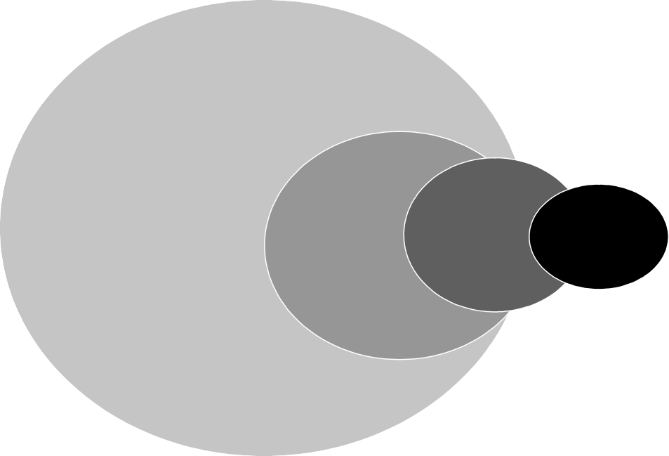

SOCIAL RESPONSES
Collective
efforts focused
on keeping the
group or community alive.
POLITICAL RESPONSES
Organized clandestine challenges to persecution
INDIVIDUAL RESPONSES
Unorganized responses by individuals.
ARMED RESPONSES
Violent, confrontational challenges to persecution

This graphic suggests the proportional use of various types of Jewish responses to Nazi persecution.

Scroll of Agony by Chaim Kaplan. Diary. Pages 242-245.
- What kind(s) of response(s), based on the diagram above, is Kaplan describing?
- What does it tell you about the mindset of the Jewish community that they continued to educate their youth? How do they see their future in the ghetto?
- Why is dancing a mitzvah? Again, what does it tell you about the mindset of the Jewish community in the ghetto?
- How do you categorize the use of pork fat by religious Jews?
Smoke Over Birkenau by Liana Millu. Personal narrative. Pages 13-19.
- What kind(s) of response(s), based on the diagram above, is Millu describing?
- Why was she afraid to be separated from “the French girls, who were [her] good friends?”
- Why is it significant that Lili spoke to Lianka even before she recognized her?
- What does having a friend in her new commando mean to Lianka?
- Discuss the difference in opinion Lili and Lianka have when it comes to their appearance.
“Bialystock Resistance Debate” in Documents on the Holocaust edited by Yitzhad Arad and others. Pages 296-301.
- What kind(s) of response(s), based on the diagram above, is the group describing?
- What does this passage tell you about how news traveled through WWII Europe? How does that affect or fail to affect Jewish responses?
- Why are these decisions “choiceless choices”?
- What is the significance of the reference to Musa Dagh?
- Given that there is agreement to mount an armed resistance, what are these young people debating? What does their discussion tell you about what they think the outcome of their actions will be and their sense of responsibility to the Jewish community?

Five Chimneys by Olga Lengyl. Personal narrative. Pages 11-15.
- What kind(s) of response(s), based on the diagram above, is Lengyl describing?
- Which of Lengyl’s decisions in this passage are “choiceless choices”?
- Why are these decisions “choiceless choices”?
- Discuss the effect news from across Europe had on the Lengyls. How did this information affect or fail to affect their decision making? What does this passage tell you about how news traveled through WWII Europe?
- Do you believe that Olga was really the “author of [her] parents’ misfortunes, and of [her] children’s as well”? Why or why not? Would staying in Cluj have changed the fate of this family?

