4-H
ABOUT:  4-H, founded in 1902, is a youth development program of the National Institute of Food and Agriculture (NIFA) within the U.S. Department of Agriculture (USDA). It is implemented through the Cooperative Extension programs of the land grant universities (such as K-State; Iowa State; University of Missouri, Columbia; Oklahoma State). All U.S. states and some territories have land grant universities with Cooperative Extension programs. 4-H is the largest youth development program in the U.S., serving youth in rural, urban, and suburban communities.  4-H is open to all youth ages 8-18. Older members mentor younger members. Youth lead their clubs and make decisions using parliamentary procedure. Parents serve as club advisors or project guides as youth pursue areas of interest such as cooking, photography, space tech, woodworking, or pet care.  4-H PLEDGE:  I pledge my head to clearer thinking,  my heart to greater loyalty,  my hands to larger service, and  my health to better living,  for my club, my community, my country, and my world.  The 4-H Pledge [written by Otis Hall, state leader in Kansas] was officially adopted in 1927. The words “and my world” were added in 1973.  4-H MOTTO: To Make the Best Better  4-H SLOGAN: Learn by Doing |   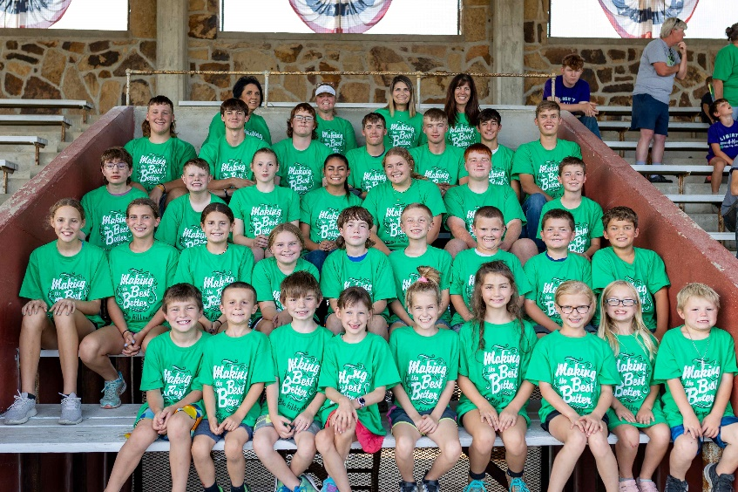  Blue Ribbon 4-H Club Members  Coffey County, KS  4-H participation is open to youth ages 8-18.  Younger children may participate as Clover Buds.
https://4-h.org/ https://4-hhistorypreservation.com/ https://www.kansas4-h.org/ Midwest Center for Holocaust Education__January 2025

