FFA
ABOUT:  The official name of the organization is the National FFA Organization. The letters “FFA” stand for Future Farmers of America. FFA was founded by a group of young farmers in 1928. In 1960, Congress granted a federal charter to FFA that was amended in 1998 and 2019. The charter allows the U.S. Departments of Education and Agriculture to work together to strengthen FFA and school-based agricultural education.  FFA is an extracurricular school activity. Participation is open to boys and girls in grades 5-12 who are enrolled in an agriculture course at their school. The teacher serves as the FFA advisor. FFA is for students who want to engage in agriculture and aspire to become farmers, teachers, doctors, scientists, engineers, or business owners.  FFA VISION:  Growing the next generation of leaders who will change the world.  FFA MISSION:  FFA makes a positive difference in the lives of students by developing their potential for premier leadership, personal growth, and career success through agricultural education.  FFA MOTTO:  Learning to Do, Doing to Learn, Earning to Live, and Living to Serve.  EXAMPLES from the FFA CODE OF ETHICS (11 total):  2. Make a positive difference in the lives of others.  - Dress neatly and appropriately for the occasion.  - Respect the rights of others and their property.  - Be courteous, honest, and fair with others.  - Communicate in an appropriate, purposeful, and positive manner.  - Demonstrate good sportsmanship by being modest in winning and generous in defeat. | 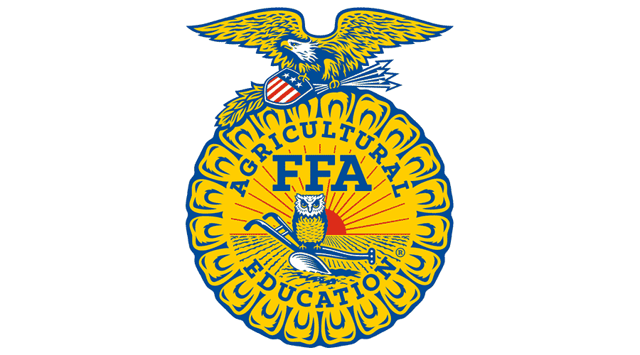  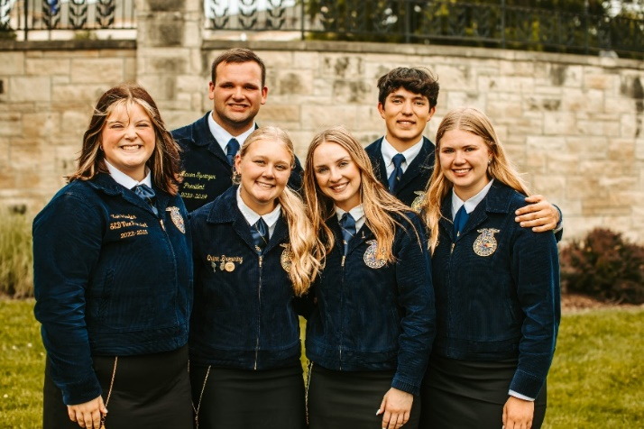  2024-25 Kansas State  FFA State Officer Team  Kansas FFA Convention | May 2024  Kansas State University
https://www.ffa.org/ Midwest Center for Holocaust Education__January 2025

