Girl Scouts
ABOUT:  After a meeting with the founder of the Boy Scouts, Juliette “Daisy” Gordon Low started the Girl Scouts in 1912 in her hometown of Savannah, Georgia. At the time U.S. women could not vote, had few educational or career opportunities, and were expected to follow strict rules concerning their behavior. The first troop consisted of 18 girls; Low wanted to help them grow into young women of courage, confidence, and character  Girl Scouts welcome K-12 participants without consideration of ethnicity, religion, citizenship status, or disability. The organization allows girls to learn and develop leadership skills in an all-girls environment. However, many troops welcome gender diverse youth.  Learning by doing is a central principle of the Girl Scout experience. Girls run their own troop meetings with the guidance of adult leaders. Scouts may earn badges, pins, and awards by developing STEM skills such as coding or robotics; outdoor skills such as archery or camping; life skills such as first aid, public speaking, or financial literacy; and creating solutions to community problems. The highest recognition is the Gold Award.  GIRL SCOUT PROMISE: “On my honor, I will try: To serve God* and my country, To help people at all times, And to live by the Girl Scout Law. * Scouts may substitute for the word God in accordance with their own spiritual beliefs. GIRL SCOUT LAW: I will do my best to be honest and fair, friendly and helpful, considerate and caring, courageous and strong, and responsible for what I say and do, and to respect myself and others, respect authority, use resources wisely, make the world a better place, and be a sister to every Girl Scout. |   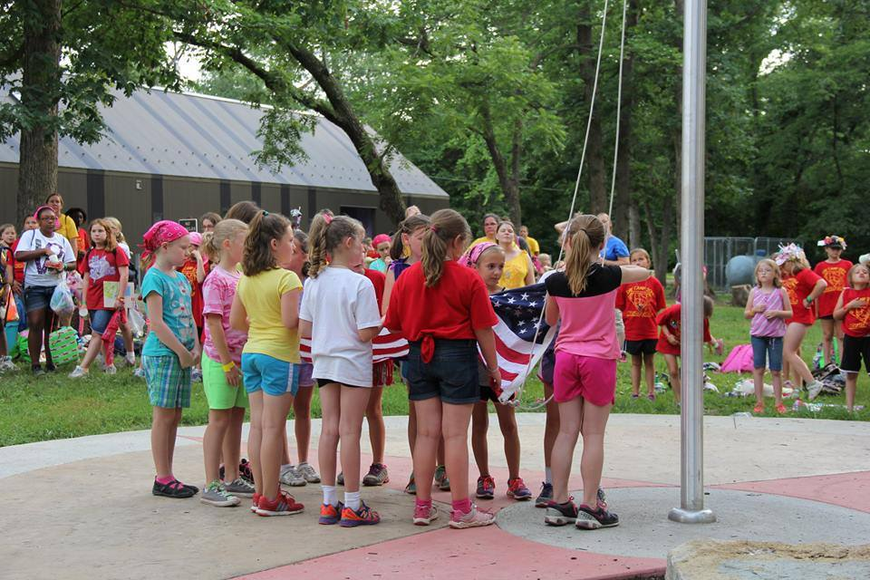  Girl Scouts of NE Kansas & NW Missouri
https://www.girlscouts.org/ https://www.gsksmo.org/ Midwest Center for Holocaust Education__January 2025

