Hitler Youth
ABOUT:  In 1922 the Nazi Party organized a group of about 1,000 boys in a group they called “Adolf Hitler Boys’ Storm Troop. In 1926 the name of the group was changed to Hitlerjugend or Hitler Youth. The Bund Deutscher Mädel (BDM) or the League of German Girls was created in 1928. In March 1939 Hitlerjugend and BDM became the only legal youth groups in Germany; the Nazis threatened to punish those who failed to join or who prevented their children from joining.  The Nazi Party believed children were the foundation for the new world they were trying to create. They had several goals for these youth groups:  - For boys, Hitler Youth was a paramilitary organization. Physical fitness was a high priority. Boys practiced military drills, learned how to use weapons, and participated in sports such as boxing. Hitler Youth was a direct pipeline to military service once WWII began.  - Physical fitness was also a goal for girls although they participated in sports that were cooperative and synchronized rather than competitive and individualized. Girls also learned skills such as sewing, nursing, cooking, and housekeeping – preparing them to mother large numbers of children for “the master race.”  - All Hitler Youth and BDM were taught the importance of conformity and obedience to the State and the Führer (Leader - a.k.a. Hitler).  - German youth were taught to hate Jews and other people thought to be racially inferior. Jews were to be treated as enemies.  - The Nazis used the groups to dominate the lives of German youth and reduce the influence of parents, teachers, ministers, and other voices of adult authority. In fact, youth were encouraged to tattle on what was happening in their homes, schools, and churches.  YOUNG PEOPLE’S OATH:  “In the presence of this blood banner which represents our Führer,  I swear to devote all my energies and my strength to the savior of our country, Adolf Hitler. I am willing and ready to give up my life for him, so help me God.”  (Sworn by ten-year-olds when first joining the Hitler Youth.) | 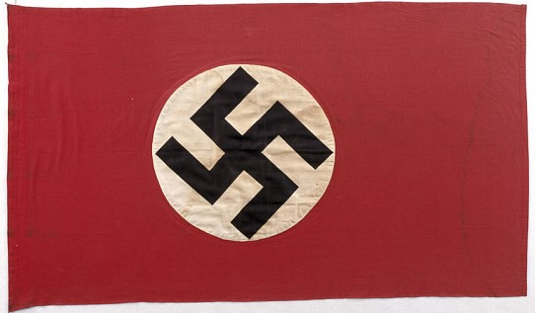  German Nazi Swastika Flag  This was the official German flag from 1935 until the end of WWII in 1945. It is not legal to display a swastika flag in Germany today.  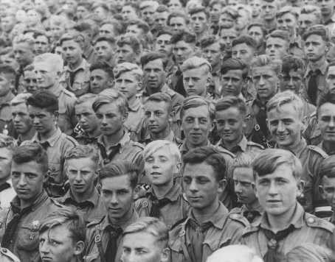  Hitler Youth members at the Nazi Party Rally in Nuremberg, Germany where the swastika flag was adopted as the national German flag. 11 Sept 1935.
https://echoesandreflections.org/wp-content/uploads/2020/12/03-02-05-01_StudentHandout_Hitlerjugend.pdf https://www.si.edu/object/nmah_1357427 https://encyclopedia.ushmm.org/content/en/article/hitler-youth-2 https://encyclopedia.ushmm.org/content/en/photo/hitler-youth-members-at-a-nazi-rally
Midwest Center for Holocaust Education__January 2025

