Scouting America (BSA)
ABOUT:  Scouting America (formerly Boys Scouts of America) was founded in 1910. It is not a government organization, although it was given a Federal charter from Congress in 1916. Scouting does not have a religious affiliation although troops often meet in and provide service to churches and synagogues. Starting in October 2017, Cub Scout dens and Boy Scout troops allowed female members. Other Scouting programs previously allowed girls to participate. Scouts of all backgrounds are welcome.  Scouting America currently has five programs targeted at various age and activities. The two most familiar programs are:  - Cub Scouts: Grades K-5. “Dens,” run by parent volunteers, are organized by grade.  - Scouts BSA: Ages 11-17. Traditional scouting. Elected youth leaders run meetings with the guidance of a Scoutmaster and others. Scouts earn merit badges by developing practical life skills, STEM skills, participating in outdoor activities, and performing community service. Highest rank is Eagle Scout.  MISSION:  The mission of Scouting America is to prepare young people to make ethical and moral choices over their lifetimes by instilling in them the values of the Scout Oath and Law.  SCOUT LAW:  A Scout is trustworthy, loyal, helpful, friendly, courteous, kind, obedient, cheerful, thrifty, brave, clean, and reverent.  SCOUT OATH:  “On my honor I will do my best to do my duty to God and my country and to obey the Scout Law; to help other people at all times; to keep myself physically strong, mentally awake, and morally straight.”  SCOUT MOTTO: “Be Prepared.” | 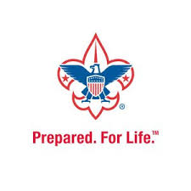  
https://www.scouting.org/ Midwest Center for Holocaust Education__January 2025

