Deportation Packing List
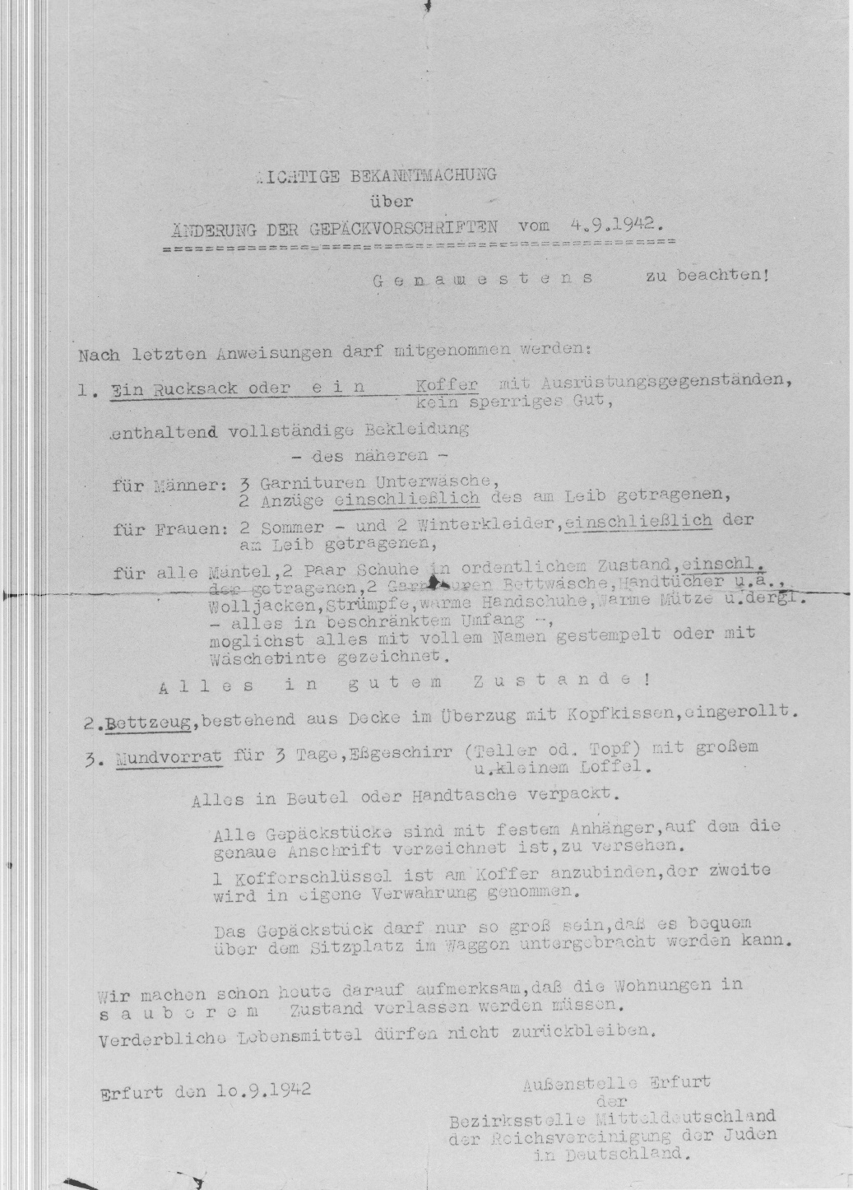 | Notice from the Erfurt Branch Office of the Central German District Office of the Reich Association of Jews in Germany (Reichsvereinigung der Juden in Deutschland), dated 10 September 1942, containing “Changes in Packing Regulations of 4 September 1942."  Important Notice concerning Changes in Packing Regulations from 4 September 1942  To be followed precisely!  In accordance with the last directives, you are allowed to take the following:  1. A knapsack or suitcase with the following equipment. No unwieldy items. Including  complete outfits, to consist of:  For men: 3 sets of underwear, 2 suits (including the one you are wearing).  For women: 2 summer and 2 winter dresses (including the one you are wearing).  For all: a coat. 2 pairs of shoes in good condition (including the pair you are  wearing), 2 sets of bed linens. Towels, and the like.  Also woolen jackets, socks, warm gloves, warm caps, and the like.  Everything is to be limited in quantity. If possible, everything is to be stamped with full name or marked in ink with laundry marks.  EVERYTHING MUST BE IN GOOD CONDITION!  2. Bedding, consisting of a blanket rolled together with pillows in a cover.  3. Provisions for 3 days, a dinner plate or pot with a large and small spoon.  Everything is to be packed in a bundle or satchel. All pieces of luggage are to contain identification tags on which the exact address is listed.  One suitcase key should be attached to the suitcase, the second key is to be kept by you. The one piece of luggage can only be as large as can be easily stored in a luggage rack above the seat in a railway car.  We are informing you in advance that apartments must be left in clean condition. Perishable foods are not to be left behind.  Translation by Shelly Cline, PhD for MCHE
Source of original document: https://collections.ushmm.org/search/catalog/pa1131244

